
Copenhagen Cadet Circuit
13th Edition

Men’s & Women’s
Individual & Team Epee
Nov 29th – Nov 30th 2025

Copenhagen Cadet Circuit

Organizers: Danish Fencing Federation and Hellerup Fencing Club
http://www.faegtning.dk
http://www.hellerupfaegteklub.dk

Friday, 28th November 2025
18:00 Weapon control and registration
20:00 Weapon control and registration close

Saturday, 29th November 2025
07:30 Venue opens
08:00 Weapon control and registration
16:00 Team inscription
Top 8 Team inscription scratch
Individual Men’s Epee  09:00 Calling  09:30 Start of pools  18:30 Semi-finals and finals  19:30 Ceremony | Individual Women’s Epee  09:00 Calling  09:30 Start of pools  18:00 Semi-finals and finals  19:30 Ceremony

Sunday, 30th December 2025
07:30 Venue opens
Men’s and Women’s Team Epee
09:00 Calling
09:15 Start of team competitions
15:30 Finals
16:30 Ceremony

Competition Format
EFC regulations apply throughout the competition.

Individual competition format
One round of pools of 6-7 fencers, approx. 20% eliminated
Direct elimination after pools, without repechage
Trophy for top 4

Team competition format
Direct elimination until 32
Pools in 32
Full placement in top 8
Teams can be entered until 16:00 Saturday

Entries
Entries for individuals and teams must be submitted through each fencer's national federation through the Website of the European Fencing Confederation. Deadline is Friday, 21st November 2025. Regulations limit each country to a maximum of 20 fencers, except the host country, which may enter a maximum of 64 fencers.

The entry fee is to be paid at the check-in registration:
Individual entry fee is 25 €
Team entry fee is 75 €

Referees
1-3 fencers  4-9 fencers  10-15 fencers  16-20 fencers | no referee required  1 referee  2 referees  3 referees
Individual competition Team competition
1-2 teams  3 or more teams | 1 referee  2 referees

Each participating country must provide trained referees in accordance with the table above, at their own expense. We are unfortunately not able to assist with finding referees. Please note that the referee count is per competition per day per gender.

All referees must be registered on the EFC site by their national federation. In the event where this requirement is not met, a penalty of 500 € will be charged for each missing referee. This penalty must be paid before the fencers from the offending country can begin to compete.

As referees are essential to the successful smooth running of the competition, referees are all required to stay until the end of the competition, so please plan travels according to the schedule.

All referees are required to participate to a seminar hosted one hour prior to the start of the competition. It will be chaired by the EFC Referees commission delegate. Participation is mandatory for the referees!

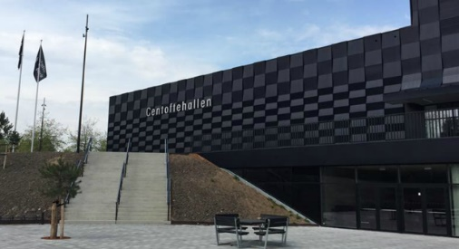
Venue
Gentofte Hallen, Gentofte Sportspark, Ved Stadion 14, 2820 Gentofte
Tel: +45 39654142
http://sportspark.gentofte.dk/da/Haller-og-lokaler/Gentoftehallen

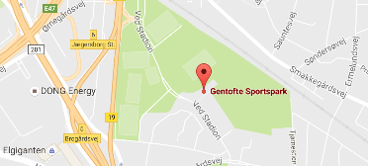
It is 10 min walk from the S-Train station Jægersborg (lines A and E)
http://www.metroeasy.com/copenhagen-s-train.html

Equipment
FIE standard equipment will be required, i.e. 800N clothing, 1600N masks who meet the safety requirements and FIE approved blades. Fencer’s name on the back of the jacket and national symbols are not required.
All masks must be approved at the weapon control before the competition starts.

Shop
There will be an Allstar shop available at the competition, where participants can purchase fencing equipment and more.

Refreshments
There will be a cafeteria present at the competition venue where you can buy coffee, water, energy drinks, snacks and food. It will be open from 07:30 on both days. Payment by card and cash is accepted.

Travel
Copenhagen Airport is the nearest airport. There are several arrivals and departures connecting Copenhagen with most of the bigger airports in Europe on a daily basis. We recommend train or metro connections from the airport:
https://www.cph.dk/en/parking-and-transport/bus-train-metro/

Accommodation
We have negotiated an arrangement with the ARP Hansen group. The following benefits have been negotiated:
1) 15% discount on the best daily flexible rate
2) Free cancellation and change up until 12 noon on arrival day
3) Discount for breakfast

Click on the link to find hotel and availability
https://www.arp-hansen.com/arpbe/web/en/login/38168215

Organization Info
Hellerup Fencing Club, Strandparksvej 46, 2900 Hellerup, Denmark
If special requirements or questions, please contact:

Patrick Jørgensen at webmaster@hellerupfaegteklub.dk or Mia Maja Frederiksen on +45 20 77 94 33

